Let’s Talk About It! Facilitating Whole-Class Discussions
Posted by Rita Platt
By Rita Platt
Students love to talk. With a new emphasis on speaking and listening ushered in by the Common Core State Standards, teachers must learn to harness this social drive and use it to pull pull the wagon of content learning.
How? Through whole-class discussions.
When I was working on earning National Board Certification, I spent many hours designing a method for facilitating literature-based discussions. Below, I share with you the method that worked best for me.
Step 1:
Decide on a theme, issue or topic to discuss and develop an essential question to go with it. It is probably best to start with either slightly controversial topics or broad themes that appeal to the age group you teach. For example, when I taught 7th grade, I used the theme of justice because my students were very keyed into concepts of what they perceived to be “fair.” The essential questions were, “What does it mean to be fair?” and “Is fair always equal?” With a 4th grade group, I used the topic of animal rights. This was a topic of keen interest to my students after they readThe One and Only Ivan by Katherine Applegate. The essential questions were, “Do animals have rights?” and “Should those rights different than those enjoyed by human beings?”
Finding themes to integrate with social studies or science topics is a good place to start. Also, it gives you a double bang for the buck because as students work on language arts skills they also learn content.
Step 2:
Choose the texts that students will read (or watch) to learn about the topic and explore differing perspectives. In the best-case-scenario, students will read a variety of texts in a number of formats all surrounding an essential question. For example an essential question I used with a 7th grade classroom was, “What does it mean to be free?” After allowing the students to do a short quick write on their initial thoughts concerning the question, we started reading.
Having an “anchor text” is helpful. This means that all students read at least one short shared text (a short-story, a poem, an article, or even a video.) In the freedom unit, we all read the short folk tale, The People Could Fly by Virginia Hamilton. We also read and analyzed a poem by Emily Dickinson, Emancipation.
After the whole-class reading was finished we moved into what I call the “individualized yet altogether” readings. These consist of various texts that students read by themselves, with partners, or in small groups. While these articles, poems, and stories all shared a theme of freedom, they are at students’ independent reading levels. For more on this method, click here. To see a resource list for finding leveled texts, click here.
Step 3:
Once students have finished their reading, Allow them a class period or two to prepare for the whole-class discussion. To scaffold students, I gave them a list of questions to answer in writing. Students used all of the texts they had read to ponder the questions (below) and write answers to them.
- What does it mean to be free?
- Is freedom more of a body-thing or a mind-thing?
- Are people free in the modern world?
- Do you think you are free?
- What text spoke most strongly to the theme?
I am very specific with students that answers must include direct textual evidence, including page numbers and quotes, so that during the discussion students can easily refer back to the texts.
Having a quiet room is important. This is not a discussion time, it is a time for students to think deeply and prepare to contribute to an intellectual conversation.
Step 4:
Prepare for the discussion by doing three things.
- Set up a video recorder with audio. This first discussion must be recorded to show to students later.
- Structure the room in such a way that all students can see each other, a circle of desks is best if you can manage it.
- Ask students to put their texts on their desks along with the answers to the questions they wrote in the previous class period(s).
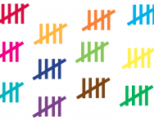Start the discussion by asking your essential question, “What does it mean to be free?”
Here is where it can get tough for a teacher:
DON’T TALK!
Let the students talk. The point is for them to develop independent discussion skills, right? The teacher’s role is to guide that learning.
As students talk, chart participation. This can be as simple as tallying the number of times each students speaks or as complex as mapping who speaks to whom. There may be some uncomfortable silences. There may be some interruptions. There may be some students who talk too much or who never talk at all. The conversation might flee from the topic.
That’s okay. Here’s why…
Step 5:
It is after this first class discussion that all of the learning happens. You will use students’ nascent conversation as a video-text to have students analyze their participation, decide on strengths and needs at the individual and group levels, and to develop a rubric to guide them in their next discussion.
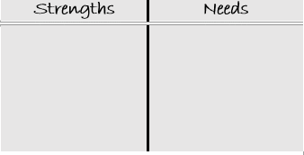Have students watch the video recording of their discussion. As they watch, ask them to fill in two “T” charts. One labeled, “My Discussion Strengths/Needs” and one labeled, “The Class’ Discussion Strengths/Needs.”
Ask students to share their findings and use them to make a rubric or a checklist of what a good whole class discussion looks and sounds like. Sample rubrics/checklists can be seen here, here, and here.
Have students write personal goals for their participation in the next discussion.
Some goals my students wrote were:
“I will talk at least three times.”
“I will try hard to include someone who isn’t talking.”
“I use refer to the page of the text I am talking about.”
“I will try not to interrupt.”
Step 6:
Repeat! Have students repeat the same discussion, video tape it again, and have students process their performance and the performance of the class as a whole using the “T” chart above and/or the class-created rubric.
Celebrate growth and start planning for the next whole-class discussion! My students liked the discussions and I felt that they were valuable enough that I generally facilitated one per quarter in my junior high classroom.
Further Resources:
After you have a whole-class conversation under your belt, you will likely need to do some direct instruction with students on some of the needs you noted.
Common concerns include:
- No one talked.
- Some were off topic.
- Interruptions.
- Students didn’t go deep enough.
- There was not a real conversation, it was more like kids making a series of comments.
- Some kids talked too much or not enough.
Don’t let these things discourage you! Learning is a process. Each time students discuss, it will get better and more fluent.
Below are resources that can help you problem-solve!
Todd Finley offers a critique of discussions as they often are and a how-to for making them better.
The Big List of Class Discussion Strategies by Jennifer Gonzalez shares discussion strategies different than those offered above.
Truly, if you want to facilitate a successful whole-class discussion, you have to read Jeff Zwiers. He offers resources and scaffolds for teaching students to use the academic language needed for strong class conversations no matter what format you choose.
Rita Platt (@rit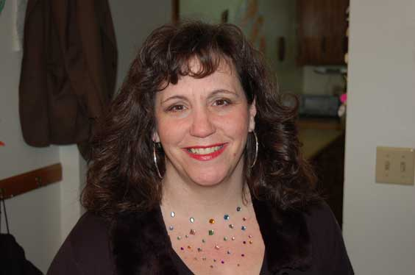aplatt) is a Nationally Board Certified teacher. Her experience includes teaching learners of all levels from kindergarten to graduate student. She currently is a Library Media Specialist for the St. Croix Falls SD in Wisconsin, teaches graduate courses for the Professional Development Institute, and consults with local school districts.
Related posts:
- Building fires: raising achievement through class discussion. Kahn, E. Kahn, E. (Mar 2007). Building fires: raising achievement through class...
- Whose interpretations matter most – teacher’s or students? An Annotation by Laurie Walsh The article begins with a...
- Tap Out! A Quick & Fun Way to Formatively Assess Almost Anything! By Rita Platt Looking for a fresh, fun way to...
- Strategies for initiating authentic discussion. Johannessen, L. Johannessen, L. (Sep 2003). Strategies for initiating authentic discussion. English...
- “Put Up a Parking Lot” – On Your Board! It's June, and your class is not asking questions about...

